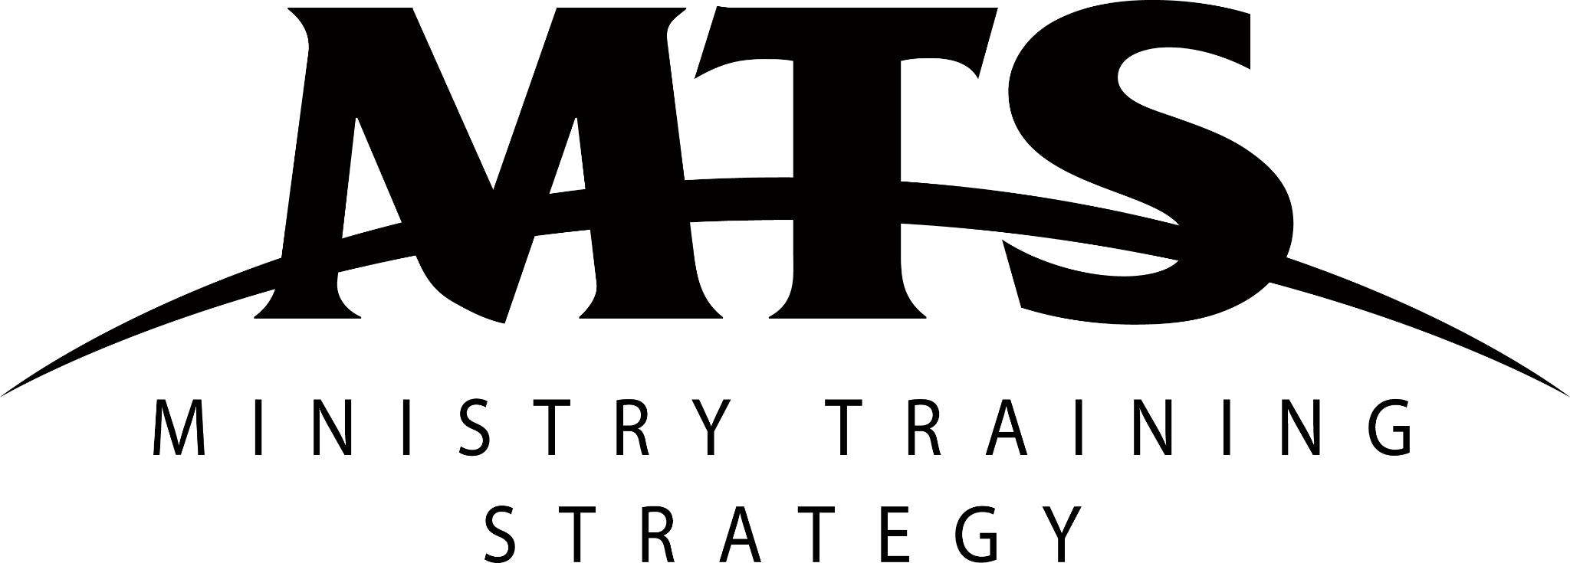
MTS Info Nights
Social Media Samples
Facebook Event Blurb
At [insert church name] we’re all about making Jesus known, both now and in generations to come. That is why we partner with Ministry Training Strategy (MTS). MTS exists to help raise up the next generation of gospel workers and equip them for a lifetime of serving Jesus.
Join us on [insert date] to find out more about MTS and what it means to receive training through a ministry apprenticeship. Potential and current MTS Trainers and Training Centres are also welcome, and are encouraged to bring their own church members along.
The night will include a short presentation exploring what MTS is, and will provide you with a chance to talk through your questions with MTS alumni who will share their firsthand experience of ministry apprentice life.
Social Posts
- Come to the [insert church name] MTS Info Night to find out why ministry training is an opportunity you should seize with both hands!
- Have you cleared [insert date] for our upcoming MTS Info Night? Join us to hear how you could train for ministry through MTS at [insert church name].
- Is MTS just another Christian acronym you don’t get? Come to our MTS Info Night on [insert date] to hear how God could equip you for ministry through MTS.
- At [insert church name] we want to raise up tons of young disciples like you as gospel workers. Come and hear more at our upcoming MTS Info Night.
- Not sure where to go next to serve God with your whole life? Maybe an MTS apprenticeship is for you? Learn all about it at our MTS Info Night on [insert date].

