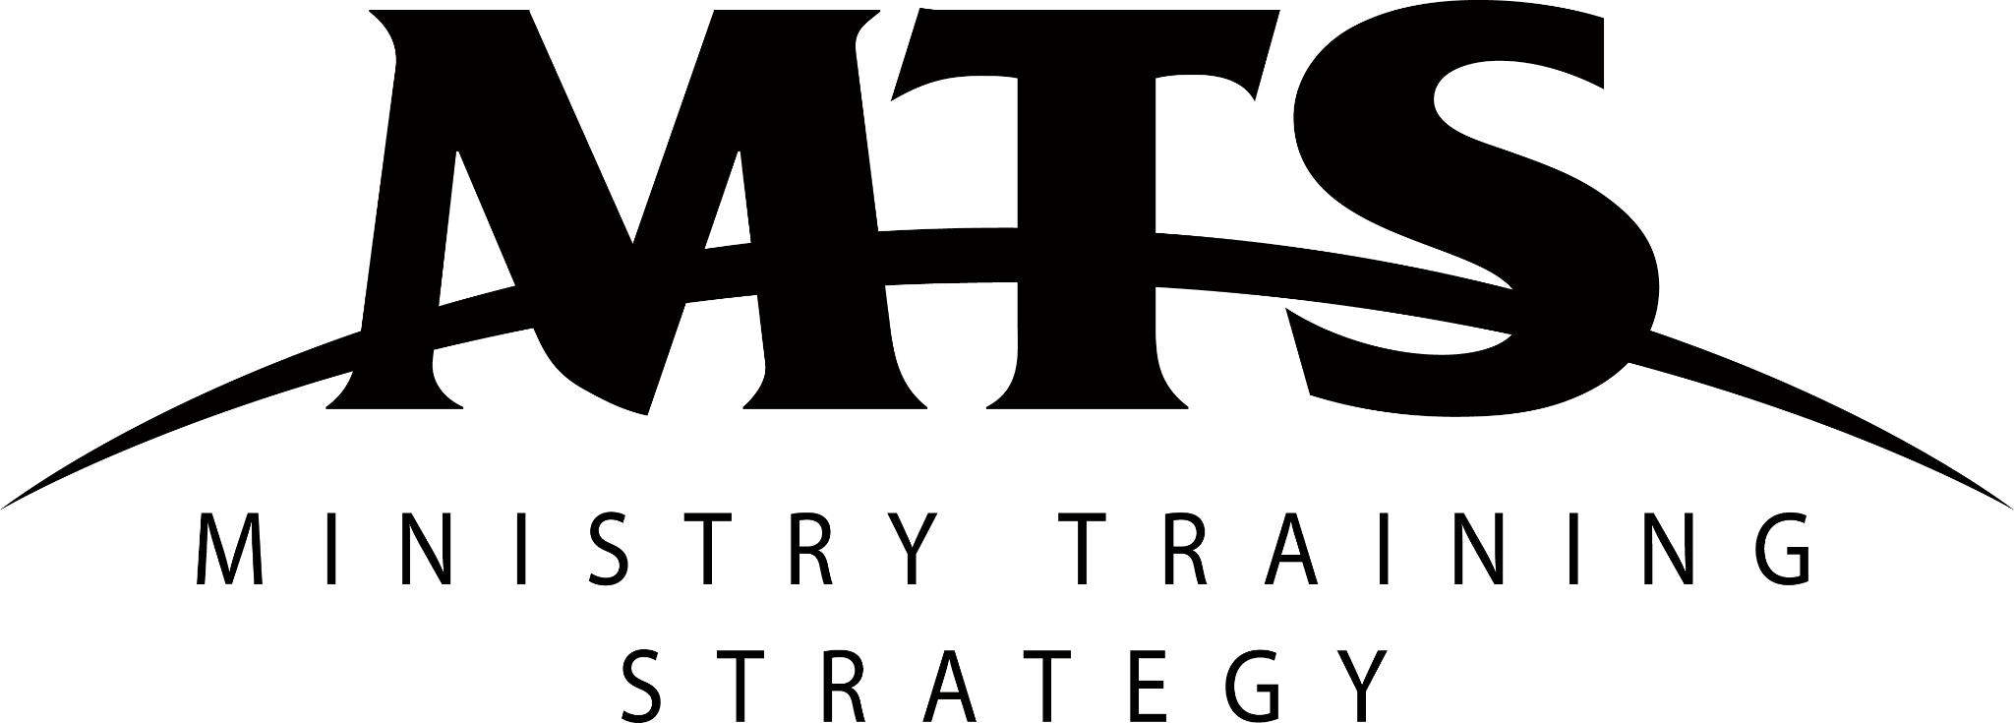
MTS Info Nights
Email Samples
EMAIL #1 | The Invitation (Pre-Event)

Dear [Person’s Name],

We hope this email finds you well.

We would like to invite you and your church to our next MTS Info Night, at [Insert Location] on [insert date].

Who are MTS Info Nights for?

- Potential Apprentices
A 1.5 hour evening event is far easier for potential apprentices to commit to, compared to a day or weekend long recruiting conference. So we encourage you and your leaders to think through who in your ministry should be considering doing an MTS apprenticeship sometime in the next four years, and invite them to an MTS Info Night. We say four years because that is how long it takes on average from the first conversation with a potential apprentice to them beginning an apprenticeship. The vast majority of MTS Apprentices undertake the program because they have been personally asked to consider it by church staff or a lay leader they have a relationship with.

- Potential Trainers and Training Centres
MTS Info Nights are also helpful for potential MTS Trainers who have had little exposure to MTS. These people are likely to be members of your church leadership team or are currently studying at Bible College. We also encourage churches to bring along key lay leaders such as treasurers and parish council members, to help them better understand what MTS is about and explore how they can implement MTS in their church.

- Family and Friends
Most parents and friends (potential supporters) of potential apprentices find MTS Info Nights helpful, as they are free to clarify any questions they have about the MTS program.

Please let us know if you are planning on coming with others, by clicking ‘going’ on our Facebook Event.

We look forward to seeing you there.

In Christ,
[Sender’s Name]

EMAIL #2 | Invitee Follow-Up (Pre-Event)
Dear [Person’s Name],

We hope this email finds you well.

We just wanted to follow up on the email we sent you a few weeks back about our MTS Info Night at [Insert Location] on [insert date].

If you want to know a bit more about the night to help you in your decision, we can tell you that over the 1.5 hour session we will discuss what MTS is about, the biblical foundation for ministry apprenticeships, and the realities and next steps for ministry apprenticeships for trainers, apprentices and training centres.

We will interview a [current/past] MTS apprentice and trainer, and hear about their experience of the program, as well as have a Q&A where you and your guests can ask any questions you have about MTS.

Please let us know if you are planning on coming with others, by clicking ‘going’ on our Facebook Event.

We look forward to seeing you there.

In Christ,
[Sender’s Name]

EMAIL #3 | Attendee Next Steps (Post-Event)
Dear [Person’s Name],

We hope this email finds you well.

We would like to say a huge thank you for joining us at our MTS Info Night at [Insert Location] on [insert date]. We were greatly encouraged to see people and churches gather to ask how they could serve Jesus with their whole lives.

On the night we mentioned a few next steps for people at different stages of thinking, and that’s what this email is about. So please have a read of your next step and get in contact with us or directly with MTS to find out more.

Potential Apprentice - Next Step
If you are considering pursuing an MTS Apprenticeship, please seriously consider attending MTS Recruit this October - November at one of the MTS Recruit Local Conference Gatherings. MTS Recruit is a conference designed to provide Delegates (that’s you!) with a space to ask their questions with others in the same stage of thinking, have one-to-one mentoring chats, and delve deeper into what God’s Word has to say about Gospel Work. If you would like to find out more, head to their website at www.mtsrecruit.online or email the MTS Events Coordinator at events@mts.com.au.

Potential Trainer - Next Step
If you are considering becoming an MTS Trainer, congratulations! Thank you for being willing to train and equip the next generation of Gospel Workers for a lifetime of serving Jesus. Your next step involves contacting Russ Smidt, the MTS Director of Training, who will talk you through the how, what and when of your next steps. You can contact Russ on 0431 015 292 or at rsmidt@mts.com.au.

Potential Training Centres - Next Step
If you are considering becoming an MTS Training Centre, please contact Russ Smidt, the MTS Director of Training, who will talk you through the how, what and when of your next steps. You can contact Russ on 0431 015 292 or at rsmidt@mts.com.au. Then also discuss with your church leadership team and parish council members the need to set aside a budget for an MTS Apprentice for next year and beyond.

We hope and pray that God will bless you as you seek to serve and work alongside Him in growing His Kingdom.

In Christ,
[Sender’s Name]

EMAIL #4 | Recruiting Conference Invite (Post-Event)
Dear [Person’s Name],

We hope this email finds you well.

At this year’s MTS Info Night, we shared with you that MTS runs an annual international recruiting conference called MTS Recruit. MTS Recruit runs at different locations over October - November. This is your invite to join me and my church [insert church name] at the [insert MTS Recruit Local Conference Gathering name] on [insert dates].

The MTS Recruit conference is designed to provide Delegates (potential apprentices) with a space to ask their questions with others in the same stage of thinking, have one-to-one mentoring chats, and delve deeper into what God’s Word has to say about Gospel Work.

If you would like to find out more, head to their website at www.mtsrecruit.online or email the MTS Events Coordinator at events@mts.com.au. Otherwise, we can’t wait for you to join us as we consider what it means to serve Jesus with our whole lives.

In Christ,
[Sender’s Name]

