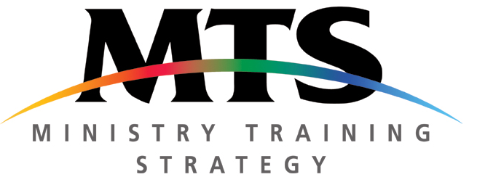
MTS Info Night
Example Social Media

Following are examples you could use to advertise your MTS Information Night using social media.
Facebook Event
At [insert training centre name] we’re all about making Jesus known, both now and in generations to come. Ministry training is about raising up the next generation of gospel workers and equipping them for a lifetime of sharing Jesus.
Join us on [insert date] to find out more about MTS and how you can be trained for ministry through an apprenticeship at [insert training centre name].
The night will include a short presentation exploring what MTS is, and what it would mean for you to undertake an apprenticeship. We also want to talk through your questions and there will be opportunities to find out firsthand what the ministry apprentice life is like as we hear from some of our MTS alumni.

Tweets
- Come to the [insert training centre name] MTS Info Night to find out why ministry training is an opportunity you should seize with both hands!
- Have you cleared [insert date] for the MTS Info Night? Join us to talk about how you could train for ministry through MTS at [insert training centre name].
- Is MTS just another Christian acronym you don’t get? Come to the Info Night on [insert date] to hear how God could equip you for ministry through MTS.
- At [insert training centre name] we want to raise up tons of young disciples like you as gospel workers. Give it some thought at our MTS Info Night.
- Not sure where to go next to serve God with your whole life? Maybe an MTS apprenticeship is for you? Think about it at the Info Night on [insert date].

